

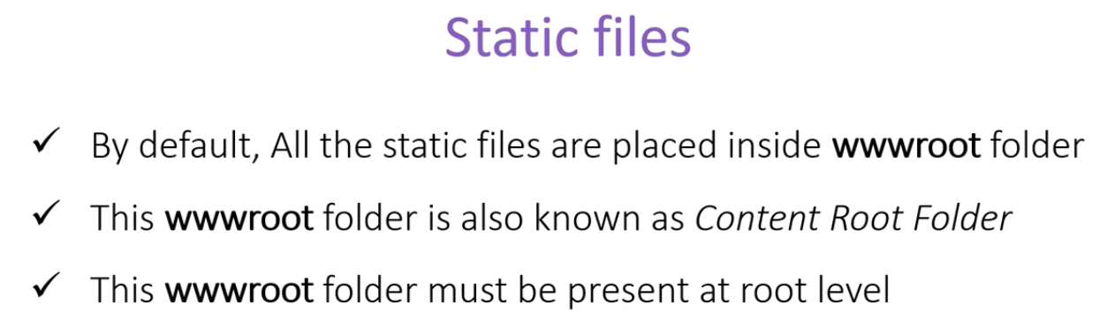

* **wwwroot**  is the default content folder of the application. Since we are using the default content folder, there is no need to include the name in our application when we link to a static file.



Notice how we didn’t write **src=”~/wwwroot/images/logo.png”** .

* In order to use the static files, we need to configure our application to use the static files. That we do in our **startup** class file in the **configure()** method.



* In case we want to use another folder for static file, instead of the default wwwroot folder, there can be two scenario:
  + We want to use both wwwroot folder and the other folder, in this case we have to configure it like below



And then we can access the new folder as well. Unlike the wwwroot folder where we could skip the rootfolder name in the link, here we must provide the full path.



* + We only want the new folder only, in that case we just exclude the app.UseStaticFiles(); method from the configure of startup class.